Coding Practice Questions

1. Write a routine in **python** that does the following:

* 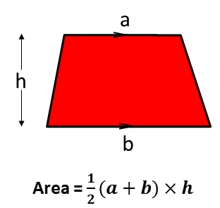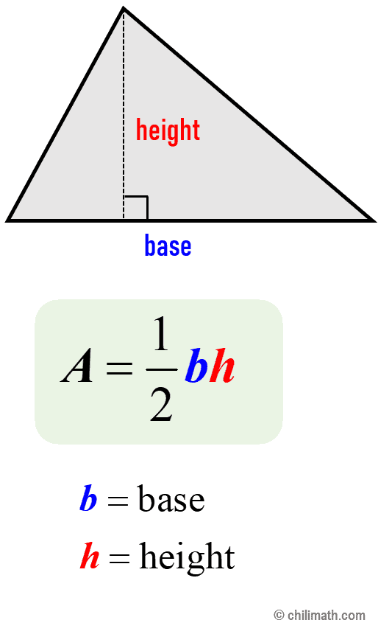Asks the user to choose “triangle” or “trapezium”
* Asks the user to input the appropriate lengths to calculate the area of the chosen shape.
* Calculates the area of the shape
* Outputs the value to the user.

|  |  |  |  |
| --- | --- | --- | --- |
|  |  |  | print(“Enter a for triangle or b for trapezium”.) |
|  |  |  | choice = input(“Enter a or b: “) |
|  |  |  | if (choice == “a”) : |
|  |  |  | b = input(“Enter length of the base: “) |
|  |  |  | h = input(“Enter height: “)  print(“Area of the triangle is “ + float(0.5 * b * h)) |
|  |  |  | elif (choice == “b”) : |
|  |  |  | a = input(“Enter length of the top: “) |
|  |  |  | b = input(“Enter length of the base: “) |
|  |  |  | h = input(“Enter height: “) |
|  |  |  | print(“Area of the trapezium is “ + float(0.5 * (a + b) * h)) |
|  |  |  | else |
|  |  |  | print(“You have chosen poorly.”) |
|  |  |  | fi |
|  |  |  |  |
|  |  |  |  |

1. You may use the following list in this question:

|  |  |  |  |  |  |  |  |  |  |
| --- | --- | --- | --- | --- | --- | --- | --- | --- | --- |
|  | [0] | [1] | [2] | [3] | [4] | [5] | [6] | [7] | [8] |
| Arr = | [5, | 8, | 11, | 22, | 13, | 16, | 4, | 17, | 34] |

In python write a routine that does the following.

* Checks every element in the list (arr)
* Counts the number of elements that have a value between 10 & 20.
* Outputs the result to the user.

The expected output for this routine using the list arr is 4

|  |  |  |  |
| --- | --- | --- | --- |
|  |  |  |  |
|  |  |  |  |
|  |  |  |  |
|  |  |  |  |
|  |  |  |  |
|  |  |  |  |
|  |  |  |  |
|  |  |  |  |
|  |  |  |  |
|  |  |  |  |
|  |  |  |  |
|  |  |  |  |
|  |  |  |  |
|  |  |  |  |
|  |  |  |  |

1. At sea level, water boils at 100oC. For every 300m above sea level, the boiling point is lowered by 1oC.

Using python, write a routine that does the following:

* Asks the user to input an altitude e.g. (8,849m = The height of mount Everest’s peak)
* Rounds this number to the nearest 300m (e.g. 8700)
* Calculates the temperature at which water boils at this altitude. (e.g. 71oC)
* Outputs this result

|  |  |  |  |
| --- | --- | --- | --- |
|  |  |  |  |
|  |  |  |  |
|  |  |  |  |
|  |  |  |  |
|  |  |  |  |
|  |  |  |  |
|  |  |  |  |
|  |  |  |  |
|  |  |  |  |
|  |  |  |  |
|  |  |  |  |
|  |  |  |  |
|  |  |  |  |
|  |  |  |  |
|  |  |  |  |

1. On a commercial flight to New York, the average prices of tickets are shown in the table:

|  |  |
| --- | --- |
| Economy | £795 |
| First-Class | £2,980 |

The airline estimates that, on average, **each** **passenger** spends £5.33 on food and drinks purchases while on-board.

Write a routine in python that does the following:

* Asks the user to input the number of first-class passengers
* Asks the user to input the number of economy passengers
* Calculates the total revenue (income) from the sale of tickets
* Calculates the expected revenue from food and drinks purchases during the flight
* Outputs the total expected revenue.

|  |  |  |  |
| --- | --- | --- | --- |
|  |  |  |  |
|  |  |  |  |
|  |  |  |  |
|  |  |  |  |
|  |  |  |  |
|  |  |  |  |
|  |  |  |  |
|  |  |  |  |
|  |  |  |  |
|  |  |  |  |
|  |  |  |  |
|  |  |  |  |
|  |  |  |  |
|  |  |  |  |
|  |  |  |  |

1. A chat room stores the usernames of its active members on a list called users.

users = [“Bob”, “Tim”, “Ann”, “Jen”]

You will write a routine that will display a message to new users allowing them to select a valid username.

Write a routine that does the following:

* Asks the user to input a username
* The routine should keep asking the user to enter a username until the following conditions are met.
  + The username is longer than 5 characters
  + The username is not already in use (i.e. not already in the list)
  + Once these conditions are met, the routine should display a message to the user to tell them they logged in successfully.

|  |  |  |  |
| --- | --- | --- | --- |
|  |  |  |  |
|  |  |  |  |
|  |  |  |  |
|  |  |  |  |
|  |  |  |  |
|  |  |  |  |
|  |  |  |  |
|  |  |  |  |
|  |  |  |  |
|  |  |  |  |
|  |  |  |  |
|  |  |  |  |
|  |  |  |  |
|  |  |  |  |
|  |  |  |  |